**Advanced Asset Pricing: Monte Carlo Simulations**

**1. What Is a Monte Carlo Simulation?**

The idea is to generate a large number of sequences of an underlying process (e.g., time series for prices / returns, interest rates etc.). These are then used as input into a function whose output is of interest (e.g., a pricing function used to price derivatives.

**2. A Warm-Up Example**

See: $dices.R$

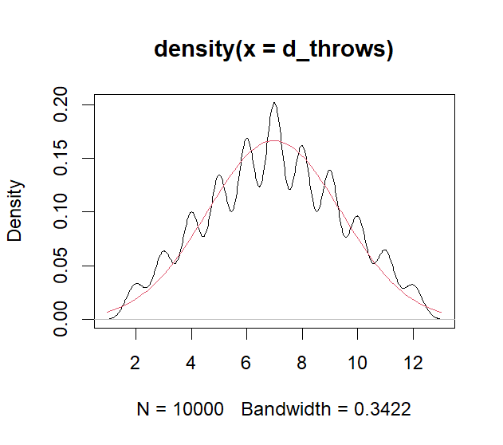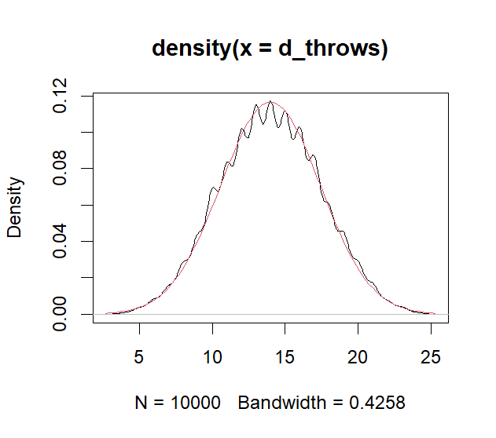

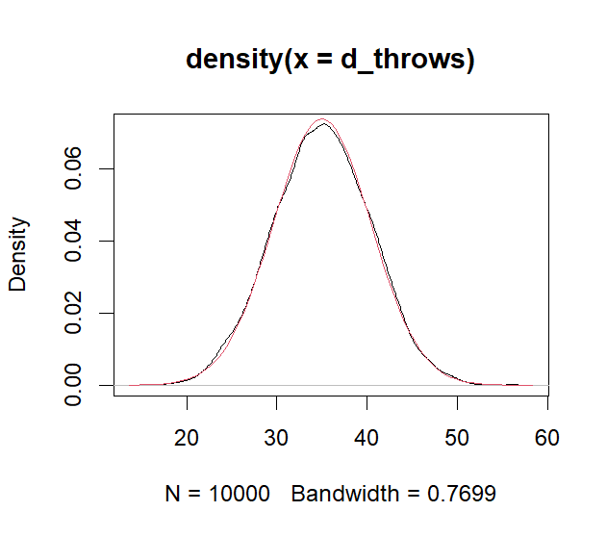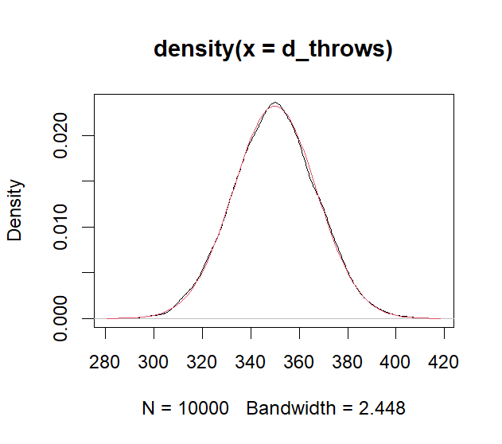

**Fig.** Top-left: $d=2$.Top-right: $d=4$. Bottom-left: $d=10$. Bottom-right: $d=100$. The density converges to that of a normal distribution due to the *central limit theorem, CLT*.